Exposures to Allergenic Pollen for General U.S. Population

# Abstract

Airborne allergens such as pollen, which has been reported to act synergistically with common air pollutants, such as ozone, will cause allergic airway disease (AAD) and dermal disease. We calculated both the temporal and spatial distributions of pollen concentrations in nine climate zones based on either the mechanistic models or statistical models using ArcGIS and VERDI. Census data were used to generate a demographic distribution by age and sex in nine climate zones in the United States. A probabilistic model was developed by considering the micro environmental dynamics of the pollens in conjunction with the activity patterns of the population. Main processes considered in the model were micro environmental transport and deposition and dermal transfer of pollens when people come in contact with airborne pollen in pollen seasons. Estimates of exposure to allergenic pollen were obtained by using the Monte-Carlo method in Matlab for each of the climate zones in the U.S. Finally, we used global sensitivity analysis to estimate the sensitivity of physical parameters in this model which consists of three different exposure routes (inhalation, dermal contact, and ingestion) to determine their relative importance.

# Introduction

Airborne allergenic pollen, which has been found to act synergistically with common air pollutants, such as ozone, will cause allergic airway disease (AAD) and related rising public health costs (Lamb, Ratner et al. 2006, Singh, Axelrod et al. 2010). One third of the US population are impacted by allergic diseases, including asthma, hay fever, rhinitis, and atopic dermatitis(Bielory, Lyons et al. 2012). These allergic diseases can be potentially triggered and exacerbated by allergenic pollen, such as birch and oak, under climate change scenarios (Shea, Truckner et al. 2008). Synergism of pollen with other common atmospheric pollutants under conditions of climate change has been identified and has enhanced the severity of AAD (Adhikari, Reponen et al. 2006).

Exposures to allergenic pollen can occur via inhalation and dermal contact (Sofiev, Belmonte et al. 2013), as well as unintentional ingestion (Cohen, Yunginger et al. 1979) (Bousquet, Dhivert et al. 1985)

# Background Information

## Pollen and allergy

Rhinitis, conjunctivitis and asthma are often considered as the typical clinical pictures of allergy to pollen, and they often occur in the same patient simultaneously during the pollen season (Sofiev, Belmonte et al. 2013). Asthma is a chronic inflammatory disease of the airways characterized by recurrent episodes of wheezing, breathlessness, chest tightness and coughing (Bateman, Hurd et al. 2008). Exposure to allergens represents a key factor among environmental determinants of asthma, which also include air pollution (Eder, Ege et al. 2006). IgE plays an essential role in hypersensitivity,(Gould, Sutton et al. 2003) which manifests various allergic diseases, such as allergic asthma and allergic rhinitis. Allergic rhinitis is thereby defined as a symptomatic disorder of the nose induced by an IgE-mediated inflammation after allergen exposure of the membranes lining the nose. Symptoms of rhinitis include rhinorrhea, nasal obstruction, nasal itching and sneezing which are reversible spontaneously or (Brożek, Bousquet et al. 2010) under treatment. Pathophysiological and clinical studies have strongly suggested a relationship between rhinitis and asthma. However, epidemiology provides the most convincing data, showing that the prevalence of asthma in patients with rhinitis varies from 10 to 40 % depending on the study (Sofiev, Belmonte et al. 2013). Moreover, allergic rhinitis is correlated to, and constitutes a risk factor for, the occurrence of asthma. Taken together, these data have led to the concept that upper and lower airways may be considered as a unique entity influenced by a common, evolving inflammatory process (Passalacqua and Durham 2007). Conjunctivitis is also commonly associated to pollen-induced rhinitis.

Sensitization occurs at the site of allergen exposure, such as airways, but can also occur through the dermal tract. However, not everybody who is exposed will become sensitized and have allergies. Aside from the individual exposure conditions, there is a high variability in the individual responsiveness to a given allergen dose.

The most important allergen carriers in the outdoor air as well as in the indoor air are pollen – with a diameter between 15 and 60 µm – from anemophilic plants such as trees, grasses and weeds. In this thesis, we discuss five different species, which are ragweed (Ambrosia), mugwort (Artemisia), birch (Betula), grass (Gramineae) and oak (Quercus). However, whole pollen grains are too large to penetrate the small airways. Since pollen is able to evoke IgE-mediated allergic reactions within seconds after contact with the mucosa, pollen allergens must be extremely water soluble and readily available. In fact allergen liberation from pollen grains can occur on the mucosal surface of the upper respiratory tract after exposure to pollen (Behrendt and Becker 2001). Symptoms can be explained by the interaction between the antigen and its corresponding IgE antibody and this phase is situated at the end of a cascade of events leading to allergy.

## Pollen Season

Different methods of observations and measurements, such as phenological events and pollen counts could be used to trace back to the same phenomenon, the flowering of plants. Similarly, both kinds of data can be modeled in many respects using a similar set of observation-based models. The first measurements are the regression models which could be used to predict phenological phases and start date and end date of the starting date of the pollen season, and the peak value. The second one is the phenological models which would also predict the entry dates of phenological phases as well as the start, peak and end of the pollen season. Phenological models are sometimes classified into the class of process-based models (Chuine, Belmonte et al. 2000), the reason is that they are mainly based on assumptions rooted in experimental results on plant physiological responses to various environmental variables. In this article, pollen counts are used as the key data to calculate the length and start date of the flowering, thus the regression model are a suitable measurement to predict this parameters.

## Data Collection

### Pollen Data Collection

Observed airborne pollen data from 85 monitor stations from 1994 to 2010 at nine different climates zones in the US (Figure 4) (Figure 5) were studied to examine the annual mean and peak value of daily concentrations of five different species of pollens (Ambrosia, Artemisia, Betula, Gramineae, and Quercus). Regression analyses were used to simulate start dates and season lengths of these five different kinds of pollen for the 17 years’ data in contiguous US (CONUS).

### Population Data and Exposure Factors

The population data is from the United States census bureau. The demographic data contains the general population information (Census Bureau. U.S 2010), in which the state-level population is classified by age group and sex. We combined those data, using ArcGIS to generate the population data on age and sex in 9 different climate regions to couple with the corresponding pollen data. In order to eliminate the inconsistent in population, normalization method are used to scale the size of the population down in each climate region. The age and sex composition remains consistent in the normalization process.

The Exposure Factor data were obtained from USEPA’s Exposure Factors Handbook (U.S. Environmental Protection Agency 2010). These factors include the value of inhalation, dermal contact frequency, skin surface, hand surface, indoor time/outdoor time and other exposure factor data in different age groups and sex. In each age group, ten different percentiles level (5th, 10th, 25th, 50th, 75th, 90th, and 95th) and mean values of exposure factors are used to generate the exposure scenario in the nine climate zones.

These exposure factor data are all in country-level. Inhalation rate distribution and other exposure factors are the same for different climate regions, although the temperature, illumination time and other environmental factors may surely affect values of those factors.

## Exposure Method Selection

### Inhalation

Exposure can be quantified by multiplying the concentration of an agent and the exposed duration. Exposure can be instantaneous when the contact between an agent and a target occurs at a single point in time and space. The summation of instantaneous exposures over the exposure duration is called the time-integrated exposure. Equation shows the time-integrated exposure(Fogh and Andersson 2000).



where:

1. E = Time-integrated exposure (mass),
2. t2– t1 = Exposure duration (ED) (time),
3. C = Exposure concentration as a function of time (mass/volume).
4. I = Inhalation factors (volume/time).

Time-averaged exposure was obtained by dividing the integrated exposure by exposure duration.

In the current study, since the time step is 1 day, we integrated the concentration through the whole pollen season (an average time about 3 months) for each species, and we used pollen counts which are considered as a more appropriate measurement of the scenario.

Then we considered the indoor and outdoor exposures as in equation and .

Outdoor:



Indoor



1. Where E = Time-integrated exposure (mass),
2. t2– t1 = Exposure duration (ED) (time),
3. C = Exposure concentration as a function of time (mass/volume).
4. I = Inhalation factors (volume/time).
5. and are ventilation rate and indoor deposition velocity, respectively.

### Dermal Exposure and Ingestion

Dermal exposure to volatile chemical compound is fully studied already (Hu, Zhang et al. 2011), however, the reports to the dermal exposure to pollen remains rare. We used dry deposition model to estimate the adherence of pollen on human skins.

The dry deposition model assumed that the transport of material to the surface is to be governed by three resistances in series: the aerodynamic resistance , The quasi-laminar layer resistance , and the surface or canopy resistance . The total resistance, by definition, is the inverse of the deposition velocity

|  |  |  |
| --- | --- | --- |
|  |  |  |

For particle dry deposition, becomes



where is the particle settling velocity

|  |  |  |
| --- | --- | --- |
|  |  |  |



|  |  |  |
| --- | --- | --- |
|  |  |  |
|  |  |  |

Where is the density of the particle, is the particle diameter, g is the gravitational acceleration, μ is the viscosity of air, and is the slip correction factor.

|  |  |  |
| --- | --- | --- |
|  |  |  |
|  |  |  |



Where Sc is the Schmidt number, St is the Stokes number, and D is the molecular diffusivity,

So the direct deposition to the skin can be calculated now

1 outdoor

|  |  |  |
| --- | --- | --- |
|  |  |  |

2 indoor

|  |  |  |
| --- | --- | --- |
|  |  |  |

Where

1. the mass of the substance on the skin surface
2. is the exposed skin area.
3. The parameters and are ventilation rate and indoor deposition velocity, respectively.

After the pollens deposit on the skin, some pollen may be adherence to the skin, and cause some allergic reaction such as redness of the skin. We use term dermal adherence rate to illustrate this effect.



Where

1. Ederm is the dermal exposure.
2. M the mass of the pollen on the skin surface
3. Sa the total surface of human skin
4. Rt the ratio of the skin which are expose to pollens(head, arm, hand, leg)
5. rm the removal coefficient of the pollens on the skin
6. Lr the dermal adherence rate

### Unintentional Ingestion

Another possible route is ingestion(Cohen, Yunginger et al. 1979).young people ,especially children, would use hands or other parts of the body which is loaded with skin to touch the mouth frequently, which would cause the unintentional ingestion of pollens. This effect may be neglected when we consider the exposure effect on adults.



Where

1. Eingest is the ingestion exposure, the mass of the pollen intake through ingestion
2. the mass of the pollen on the skin surface
3. Sa is the total surface of human skin
4. Rh the ratio of the hands in the total skin area
5. Fr hands contact with mouth frequency.

### Exposure Calculation Method

Monte-Carlo method was used to generate the exposure data. The activity data of 5000 virtual people are generating based on the corresponding exposure factor data distribution and demographic data in each climate region. For example, the data of a virtual 75 year old man data is generated by calculate the corresponding exposure data in 71-80 ages, male group. Then the observed data of pollen counts are combined with the activity data using monte-carlo method by randomly choose two values from each of the dataset and multiply them at a time. Then an exposure scenario which contains 5000 exposures will be produced. The mean of the results could be described as the population exposure to pollen.

## Sensitivity Analysis

Sensitivity analysis is the analysis of how the uncertainty in the output of a mathematical system or modeling (numerical or otherwise) can be apportioned to variety sources of uncertainty in its inputs.

Mean daily mass intake exposure to pollens was choosed as a metric for testing the system’s sensitivity to multiple inputs and parameters. Global sensitivity analysis was performed based on Morris’s Design. This design estimate the main effect of a parameter by computing a number of local sensitivities at random points of the parameter space. The mean of these randomized local sensitivities indicates the overall influence of a given parameter on the output metric, while the corresponding standard deviation indicates the effects of interacting and nonlinearity.(Zhang, Isukapalli et al. 2013)

In the current study, each of the 17 parameters(Table 1) was sampled 3600 times according to the Morris method from 200 trajectories (each has 18 steps) in the parameter space. Each of the parameters in the simulation was perturbed from 50% to 150% of its base value or its distribution while we keep other parameters unchanged in the same time.

The mean daily exposure for sensitivity analyses was normally generated using 10000 “virtual men” in each climate regions in the flowering season. Equation was used to calculate the Normalized Sensitivity Coefficients (NSC) at a local point.

|  |  |  |
| --- | --- | --- |
|  |  |  |

In this equation, the NSCi,j is the NSC for exposure route i (inhalation, ingestion, dermal) in different climate regions j. The p is the input parameter values matrix, and r is the corresponding daily mean output of the exposure effect. The Δr and Δp is the corresponding perturbation of the parameter values and perturbation of the output, respectively. The global NSC of a certain parameter, NSCg could be defined as the mean of the corresponding local sensitivities. The overall mean for each route and region could be obtained by averaging the NSC values for that route and region. In the similar way, the overall mean standard deviations are average over each exposure route and different climate regions.

## Statistics of Concentrations, Exposure and Sensitivity Analysis

To generated statistics of concentrations, surface loading, exposures and sensitivity analysis, simulations were conducted using 5000 “virtual residents” in these 9 different climate regions. Each resident will experience the whole flowering season with 5 kinds of pollens in different scenarios (outdoor and indoor).

# Result and Discussion

## Pollen Season Discussion

For most of the studied stations, comparison of mean pollen indices between the periods of 1994–2000 and 2001–2011 showed that these five different species pollen were observed to flower 1–2 weeks earlier; The observed pollen season lengths varied for Ambrosia, Artemisia, Betula, Gramineae and Quercus across the different monitoring stations in the United States. Optimum initial date and base temperature for start date was found to be 25th July for Ambrosia [Figure 9]. The start data for Artemisia is 11th April [Figure 10], the start data for Betula is 29th March [Figure 11]. The start date for Gramineae is 28th April [Figure 12] .the start date for Quercus is 22nd March [Figure 13].the pollen season lasts roughly 3months for each species, respectively. Simulation results indicated that responses of these different kinds of pollens to climate are expected to vary for different regions. Observed airborne pollen counts were obtained from monitoring stations of the American Academy of Allergy Asthma and Immunology (AAAAI) located in 9 different climate regions. The reported pollen data were classified only at the level of genus. Species under genus of Ambrosia, Artemisia, Betula, Gramineae or Quercus were not differentiated. Data used here are from March to September, which covers all the pollen season for all kinds of pollen species discussed above, the spatial distribution scenario of oak(Quercus) in 2004 is displayed as an example, using VERDI(Figure 14). Low concentrations of pollens are observed only in the southwest coast, which is in the southwest climate region. Concentration of pollen is close to zero in other climate regions

Figure 9 - Figure 13 are time series of observed daily concentrations of birch, oak, ragweed, mugwort and grass pollen from 1994 to 2010 at UMDNJ and Cherry Hill monitoring stations in New Jersey, USA. The start dates of pollen of different species are varied. The pollen season ranges from early March to late October. We also discovered that the peak values often appear in the middle of the pollen seasons. Figure 14 shows the spatial distribution of pollens of Quercus in the start date (March 15th) in the national wide scale. The peak value observed in the figure was 4 in the southwest.

The Figure 15 to Figure 19 summaries the cumulative probability of pollen concentration in different climate regions. The reported peak values were 1794 grain/m3 for Ambrosia, 1242 grain/m3 for Artemisia, 1827 grain/m3 for Betula, 1320 grain/m3 for Gramineae and 1423 grain/m3 for Quercus, respectively. Different climate regions show different pollen concentrations. In the Northeast, Central and East North Central climate regions, the mean concentrations of Betula and Quercus are the higher than those in other climate regions. In the West, South and Southwest climate regions, Ambrosia and Artemisia shows the high concentrations.

The surface loading was calculated based on small particle transport model and dry deposition model and Einstein-stokes equation. The key parameter is the pollen deposition velocity, which is 0.0909 grain/m2 for airborne pollen. This parameter is affected by many physical parameters which are listed in Table 3.

Indoor and outdoor time of human would affect the exposure scenario significantly (Zhang, Y., et al. (2013)). The ventilation rate (Ve) is the key parameter to describe the air exchange rate of indoor scenario. High value of Ve means more convection of the indoor and outdoor air, thus the concentration of pollen indoor would be more close to the concentration outdoor. The outdoor concentration of pollen is normally 5-8 times higher than indoor concentration. There are no reports shows that if this prediction about pollen concentration is valid. However, similar methods and data are reported mainly about particulate matters (PM2.5 and PM10) and pesticides (Zhang, Y., et al. (2013)).

## Exposures to Pollen

The exposures in each climate region could be compared since same number of virtual residents in each region is selected to study exposures. The 5000 residents have the same age and sex composition as the real-world demographic data.each

Figure 20 to Figure 24 show the simulated cumulative probability of residents’ daily exposures to pollen under three different exposure routes. The medians of the daily total exposures of ragweed (Ambrosia), mugwort (Artemisia), birch (Betula), grass (Gramineae) and oak (Quercus) are shown in Table 3 , respectively. Exposure data of birch(Betula) in Northeast Climate Region is used to study 3 different exposure routes Figure. Inhalation route are found to be the dominated route towards the ingestion and dermal contact route, the median of inhalation exposure is, while median of exposure through ingestion and dermal contact route is, respectively.

Route of Inhalation are calculated and shown to be the dominated route of pollen intake. The exposure from inhalation is about 100 times than the other two routes which are based on the skin contact to pollens.

## Sensitivity Analysis

The global sensitivity of the simulated exposures to different 18 parameters is illustrated in (Figure 25) (Figure 26), for Central Climate Region and Southeast Climate Region, respectively. Overall, the global NSC of all parameters varied between 0.0 and 0.35, indicating the robustness of this modeling approach. Ingestion exposure were more sensitive to parameter perturbations, with average absolute global NSC, | NSCg |, being 0.15 to 0.35. Sensitive parameters included: viscosity of air(µ), diameter of pollen(Dp), friction velocity(u*) and hand surface ratio (Sr). Inhalation exposure was less sensitive to modeling parameters. The outliers are friction velocity (u*), diameter of pollen (*Dp*), indoor time (Ind), mean free path of air molecules (λ). Total exposures has nearly the same sensitive parameters as inhalation exposure.

High interaction and nonlinearity effects among parameters were found in dermal contact and ingestion routes for pollen exposures. Average interaction effects STD being 0.3 and 0.6, respectively. Parameters with high interaction and nonlinearity effects included friction velocity (u*), viscosity of air (µ), low interaction effects were found for exposure parameters in inhalation route. They are hand to mouth frequency (Fr) .This resulted from the fact that only infants and young people often tend to touch their mouth and face using hand. And these people are only a small part of the whole population.

We can see that in different region (figure 25 and figure 26) the parameter sensitivities are slightly different. This could be explained as the effect of the proportion of different age groups of the population in each region.

The ventilation and deposition rate coefficients depend on surface characteristics, temperatures and pesticide physicochemical properties such as fugacity. Data on these dependencies are extremely limited for pollen deposition and ventilation. The values of Vd and u* used in the current study were derived from references (Hu, X., et al. (2011).) on particulate matter and small particles. Widely different pollen dermal contact effect due to hand touch have been reported in the literatures ( Brożek, J. L., et al. (2010) )( Behrendt, H. and W.-M. Becker (2001))

# Conclusion

The modeling system developed based on physical processes and human activity data and demographical data in the current study, can be easily adapted to simulated risks and exposure to particulate matter(PM) which is also believed to be a major pollutant in the air in similar environments or small scaled units such as cities or certain census. Furthermore, sensitivity analyses of the modeling system provides helpful information for planning measurements related to investigation of health risks associated with exposures to pollens or other kinds or particulate particles in the environments.

# Figure

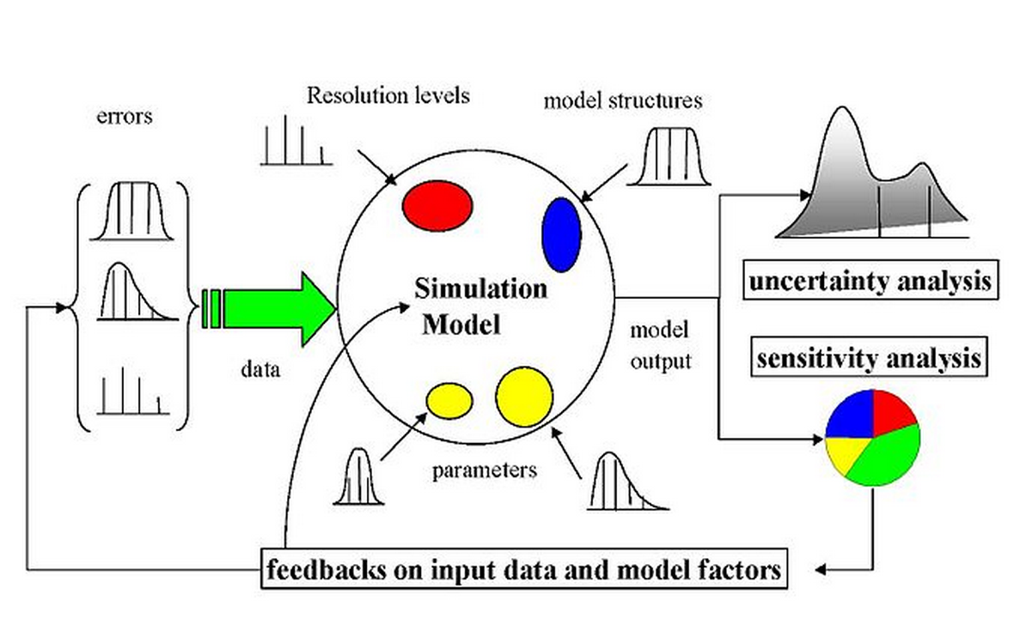

Figure 1 The scheme of a possibly sampling-based sensitivity analysis. Uncertainty would arise from different sources—errors in the data, parameter estimation procedure, and alternative model structures—they are propagated through the model for uncertainty analysis and their relative importance is quantified via sensitivity analysis.



Figure 2 Three different intake routes of the pollens.



Figure 3 Schematic diagram of modeling population exposure to pollen in 9 climate regions. Concentrations and surface loading of pollen were simulated based on observed daily pollen counts from AAAAI monitoring stations. Exposures to pollens were simulated based on the concentration profiles and activity data of different groups by ages and sex from United States Census Bureau. The intake dose calculated from exposure modeling is then used as input to conduct sensitivity analysis.

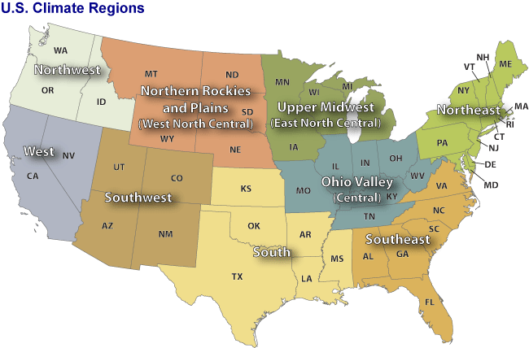

Figure 4 Nine climate regions in the contiguous United States. Through climate analysis, National Climatic Data Center scientists have identified nine climatically consistent regions within the contiguous United States which are useful for putting current climate anomalies into a historical perspective(Karl and Koss 1984)

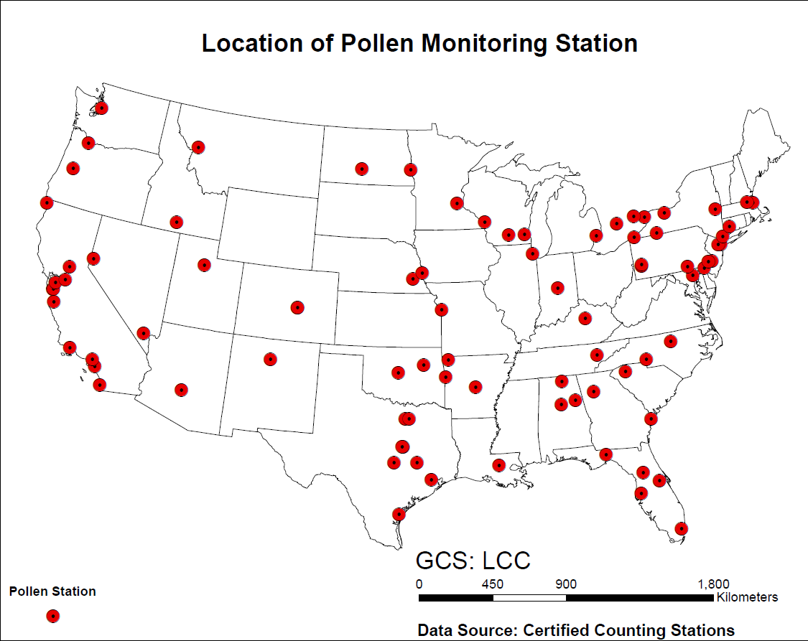

Figure 5 Locations of 87 monitor stations for airborne pollen in the United States. Pollen counts data were obtained from those monitor stations in each climate regions.



Figure 6 Activity data of human inhalation rate by weight of male and female, respectively. The data are from EFH handbook (U.S. Environmental Protection Agency 2010). There are 14 age groups from the original data resources, for each gender. The age groups are 0-1 year, 1-2 years, 2-3 years, 3-6 years, 6-11 years, 11-16 years, 16-21 years, 21-31 years, 31-41 years, 41-51 years, 51-61 years, 61-71 years, and 71-81 years. The percentiles are from 5th to 95th. (5th, 10th, 25th, 50th, 75th, 90th, 95th)



Figure 7 Activity data of human inhalation rate of male and female, respectively. The data are from EFH handbook (U.S. Environmental Protection Agency 2010). There are 14 age groups from the original data resources, for each gender. The age groups are 0-1 year, 1-2 years, 2-3 years, 3-6 years, 6-11 years, 11-16 years, 16-21 years, 21-31 years, 31-41 years, 41-51 years, 51-61 years, 61-71 years, and 71-81 years. The percentiles are from 5th to 95th. (5th, 10th, 25th, 50th, 75th, 90th, 95th)



Figure 8 Activity data of human skin area. The data are from EFH handbook (U.S. Environmental Protection Agency 2010). There are 17 age groups from the original data resources, for each gender. The age groups are 1-3 months, 3-6 months, 6-12 months, 1-2 years, 2-3 years, 3-6 years, 6-11 years, 11-16 years, 16-21 years, 21-31 years, 31-41 years, 41-51 years, 51-61 years, 61-71 years, and 71-81 years.81 years and older. The percentiles are from 5th to 95th. (5th, 10th, 25th, 50th, 75th, 90th, 95th)





Figure 9 Time series of observed daily pollen concentration of Ambrosia at Cherry Hill (top) and Newark (Bottom) monitor stations which locate in the Northeast Climate Zones. The pollen data are from National Allergy Bureau(National Allergy Bureau 2010).





Figure 10 Time series of observed daily pollen concentration of Artemisia in Cherry Hill (top) and Newark (Bottom) monitor stations which locate in the Northeast Climate Zones. The pollen data are from National Allergy Bureau(National Allergy Bureau 2010)





Figure 11 Time series of observed daily pollen concentration of Betula in Cherry Hill (top) and Newark (Bottom) monitor stations which locate in the Northeast. The pollen data are from National Allergy Bureau(National Allergy Bureau 2010).





Figure 12 Time series of observed daily pollen concentration of Gramineae in Cherry Hill (top) and Newark (Bottom) monitor station which locate in the Northeast. The pollen data are from National Allergy Bureau(National Allergy Bureau 2010).



Figure 13 Time series of observed daily pollen concentration of pollen concentration of Ambrosia in Cherry Hill (top) and Newark (Bottom) monitor stations which locate in the Northeast. The pollen data are from National Allergy Bureau(National Allergy Bureau 2010)

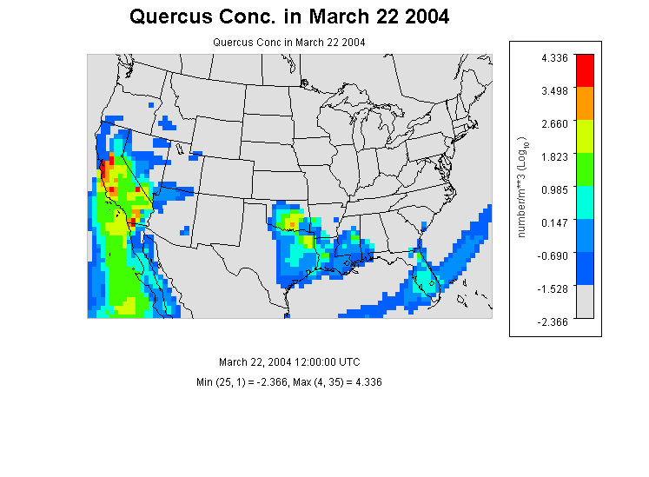

Figure 14 Quercus Concentration in the contiguous U.S. at 12:00 (UTC) in March 22 in 2004.low concentrations of pollens are observed only in the southwest coast, which is in the southwest climate region.no obvious observation of pollen are reported in other climate region.



Figure 15 The observed cumulative probability distributions of Ambrosia’s pollen concentration in the 9 nine climates regions.



Figure 16 The observed cumulative probability distributions of Artemisia’s pollen concentration in the 9 climates regions. The concentration profile in southwest is slightly smooth than in other climate regions.



Figure 17 The observed cumulative probability distributions of Betula’s pollen concentration in the 9 nine climates regions.



Figure 18 The observed cumulative probability distributions of Gramineae’s pollen concentration in the 9 nine climates regions.



Figure 19 t The observed cumulative probability distributions of Quercus’s pollen concentration in the 9 nine climates regions.



Figure 20 Simulated cumulative probability distribution of daily exposure of population to Ambrosia pollen in different climate zones. Data were from simulation results of 5000 virtual residents in each climate zones under three different exposure routes.



Figure 21 Simulated cumulative probability distribution of daily exposure of population to Artemisia pollen in different climate zones. Data were from simulation results of 5000 virtual residents in each climate zones under three different exposure routes.



Figure 22 Simulated cumulative probability distribution of daily exposure of population to Betula pollen in different climate zones. Data were from simulation results of 5000 virtual residents in each climate zones under three different exposure routes.



Figure 23 Simulated cumulative probability distribution of daily exposure of population to Gramineae pollen in different climate zones. Data were from simulation results of 5000 virtual residents in each climate zones under three different exposure routes.



Figure 24 Simulated cumulative probability distribution of daily exposure of population to Quercus pollen in different climate zones. Data were from simulation results of 5000 virtual residents in each climate zones under three different exposure routes.



Figure 25 Mean and Standard Deviation of Normalized Sensitivity Coefficient (NSC) for population exposure in Central Climate Region(Ohio Valley)(A) Inhalation (B)Dermal (C) Ingestion (D)Total Exposures The vertical dashed lines represent the NSC values of 0. Number in the figure are parameter IDs:1 u*, 2 k, 3 Dp, 4 Pp, 5 mu, 6λ, 7 Pa, 8 T, 9 Ve, 10 Tind, 11 Tout, 12 F, 13 Sa, 14 Sr, 15 Inf, 16 Inm, 17 Vd, 18 Lr.



Figure 26 Mean and Standard Deviation of Normalized Sensitivity Coefficient (NSC) for population exposure in Southeast Climate Region (A) Inhalation (B)Dermal (C) Ingestion (D)Total Exposures The vertical dashed lines represent the NSC values OF 0. Number in the figure are parameter IDs:1 u*, 2 k, 3 Dp, 4 Pp, 5 mu, 6λ, 7 Pa, 8 T, 9 Ve, 10 Tind, 11 Tout, 12 F, 13 Sa, 14 Sr, 15 Inf, 16 Inm, 17 Vd, 18 Lr,

# Table

Table Coordinates, elevation, main climate characteristics of the studied AAAAI pollen monitoring stations.

|  |  |  |  |  |  |
| --- | --- | --- | --- | --- | --- |
| **Station ID** | **Station Name** | **Lat (N)** | **Lon (W)** | **Elevation** | **Climate Region** |
| 3 | Corpus Christi, TX | 27.8 | 97.4 | 2.00 | South |
| 4 | Tampa, FL | 28.06 | 82.43 | 12.00 | Southeast |
| 9 | Tallahassee, FL | 30.44 | 84.28 | 62.00 | Southeast |
| 10 | Georgetown, TX | 30.64 | 96.31 | 91.00 | South |
| 11 | College Station, TX | 30.64 | 97.76 | 269.00 | South |
| 12 | Waco, TX | 31.51 | 97.2 | 185.00 | South |
| 17 | Dallas, TX | 33.04 | 96.83 | 207.00 | South |
| 19 | Scottsdale, AZ | 33.49 | 111.92 | 377.00 | Southwest |
| 21 | Orange, CA | 33.78 | 117.86 | 53.00 | West |
| 22 | Atlanta, GA | 33.97 | 84.55 | 366.00 | Southeast |
| 24 | Santa Barbara, CA | 34.44 | 119.76 | 57.00 | West |
| 25 | Huntsville, AL | 34.73 | 86.59 | 191.00 | Southeast |
| 26 | Little Rock, AR | 34.75 | 92.39 | 115.00 | South |
| 28 | Charlotte, NC | 35.3 | 80.75 | 229.00 | Southeast |
| 29 | Fort Smith, AR | 35.35 | 94.39 | 186.00 | South |
| 30 | Oklahoma City, OK | 35.61 | 97.6 | 340.00 | South |
| 31 | Los Alamos, NM | 35.88 | 106.32 | 2227.00 | Southwest |
| 32 | Knoxville, TN | 35.95 | 84.01 | 305.00 | Central |
| 33 | Tulsa 1, OK | 36.03 | 95.87 | 207.00 | South |
| 34 | Durham, NC | 36.05 | 78.9 | 110.00 | Southeast |
| 35 | Las Vegas, NV | 36.17 | 115.15 | 620.00 | West |
| 38 | San Jose 2, CA | 37.31 | 121.97 | 47.00 | West |
| 39 | San Jose 2, CA | 37.33 | 121.94 | 35.00 | West |
| 40 | Pleasanton, CA | 37.69 | 121.91 | 100.00 | West |
| 42 | Lexington, KY | 38.04 | 84.5 | 299.00 | Central |
| 43 | Roseville, CA | 38.76 | 121.27 | 57.00 | West |
| 44 | Colorado Springs 2, CO | 38.87 | 104.82 | 1867.00 | Southwest |
| 45 | Colorado Springs 1, CO | 38.87 | 104.83 | 1868.00 | Southwest |
| 46 | Kansas City, MO | 39.08 | 94.58 | 288.00 | Central |
| 47 | Baltimore, MD | 39.37 | 76.47 | 36.00 | Northeast |
| 48 | Reno, NV | 39.56 | 119.77 | 1382.00 | West |
| 49 | New Castle, DE | 39.66 | 75.57 | 3.00 | Northeast |
| 50 | Indianapolis, IN | 39.91 | 86.2 | 254.00 | Central |

|  |  |  |  |  |  |
| --- | --- | --- | --- | --- | --- |
| **Station ID** | **Station Name** | **Lat (N)** | **Lon (W)** | **Elevation** | **Climate Region** |
| 51 | York, PA | 39.94 | 74.91 | 13.00 | Northeast |
| 52 | Cherry Hill, NJ | 39.94 | 76.71 | 195.00 | Northeast |
| 53 | Philadelphia, PA | 39.96 | 75.16 | 12.00 | Northeast |
| 54 | Pittsburgh, PA | 40.47 | 79.95 | 287.00 | Northeast |
| 58 | Newark, NJ | 40.74 | 74.19 | 43.00 | Northeast |
| 59 | Lincoln, NE | 40.82 | 96.64 | 371.00 | West North Central |
| 60 | Armonk, NY | 41.13 | 73.73 | 187.00 | Northeast |
| 61 | Omaha, NE | 41.14 | 95.97 | 305.00 | West North Central |
| 62 | Waterbury, CT | 41.55 | 73.07 | 140.00 | Northeast |
| 64 | Chicago, IL | 41.91 | 87.77 | 189.00 | Central |
| 65 | Olean, NY | 42.09 | 78.43 | 433.00 | Northeast |
| 66 | Erie, PA | 42.1 | 80.13 | 215.00 | Northeast |
| 67 | Salem, MA | 42.5 | 70.92 | 42.00 | Northeast |
| 68 | St. Clair Shores, MI | 42.51 | 82.9 | 180.00 | East North Central |
| 69 | Twin Falls, ID | 42.58 | 114.46 | 1124.00 | Northwest |
| 70 | Chelmsford, MA | 42.6 | 71.35 | 37.00 | Northeast |
| 71 | Albany, NY | 42.68 | 73.77 | 72.00 | Northeast |
| 72 | London, ON, Canada | 42.99 | 81.25 | 250.00 | Central |
| 73 | Waukesha, WI | 43.02 | 88.24 | 270.00 | East North Central |
| 74 | Madison, WI | 43.08 | 89.43 | 263.00 | East North Central |
| 75 | Niagara Falls, ON , Canada | 43.09 | 79.09 | 188.00 | Northeast |
| 76 | Rochester, NY | 43.1 | 77.58 | 148.00 | Northeast |
| 78 | LaCrosse, WI | 43.88 | 91.19 | 216.00 | East North Central |
| 79 | Eugene, OR | 44.04 | 123.09 | 129.00 | Northwest |
| 81 | Vancouver, WA | 45.62 | 122.5 | 89.00 | Northwest |
| 83 | Fargo, ND | 46.84 | 96.87 | 277.00 | West North Central |
| 85 | Seattle, WA | 47.66 | 122.29 | 20.00 | Northwest |

Table 2 Parameters for calculating population exposure to pollens in 9 different climate regions in United States. These parameters were listed either as fixed values, known distributions or unknown empirical distribution derived from the literatures.

|  |  |  |  |  |  |
| --- | --- | --- | --- | --- | --- |
| **parameter1** | **Parameter** | **ID** | **Distribution** | **Mean(STD)** | **Range** |
| u* | friction velocity(m/s) | 1 | fixed | 1.17 | - |
| k | von karman constant(dimensionless) | 2 | fixed | 0.41 | - |
| Dp | diameter of pollen(m) | 3 | fixed | 2.00E-05 | - |
| Pp | density of pollen(kg/m3) | 4 | fixed | 840 | - |
| mu | viscosity of air (m/s) | 5 | fixed | 1.81E-05 | - |
| λ | mean free path of air molecules(m) | 6 | fixed | 6.80E-08 | - |
| Pa | density of air(kg/m3) | 7 | fixed | 1.145 | - |
| T | temperature(k) | 8 | range | 298 | 283-310 |
| Ve | ventilation rate(dimensionless) | 9 | range | 1.2 | 0.5-2 |
| Tind | indoor time(min) | 10 | norm | 1279(21) | - |
| Tout | outdoor time(min) | 11 | norm | 174(4) | - |
| Fr | hand contact with mouth frequency | 12 | empirical | 30 | 3-65 |
| Sa | human surface area(m2) | 13 | lognorm | 1.76 | 0.41-2.51 |
| Sr | hand surface ratio(%) | 14 | lognorm | 5.3 | 4.8-5.6 |
| Ihf | female inhalation rate (m3/day) | 15 | uniform | 1.33 | 0.19-1.91 |
| Ihm | male inhalation rate(m3/day) | 16 | uniform | 1.45 | 0.20-1.50 |
| Vd | indoor ventilation rate(dimensionless) | 17 | empirical | 1.75 | - |
| Lr | derm loading rate(dimensionless) | 18 | empirical | 0.0001 |  |
|  |  |  |  |  |  |

Table 3 Median of the Total Exposure Values in 9 Climate Regions (Number/Day)

|  |  |  |  |  |  |  |  |  |  |
| --- | --- | --- | --- | --- | --- | --- | --- | --- | --- |
| **Species** | **Central** | **EastNorthCentral** | **NorthEast** | **NorthWest** | **South** | **SouthEast** | **SouthWest** | **West** | **WestNorthCentral** |
| birch (Betula) | 14.2 | 13.5 | 26.1 | 45.7 | 21.4 | 18.4 | 24.8 | 19.8 | 16.5 |
| ragweed (Ambrosia) | 47.2 | 81.9 | 73.6 | 35.1 | 37.3 | 51.2 | 6.8 | 33.4 | 48.3 |
| mugwort (Artemisia) | 89.5 | 118.3 | 49.6 | 14.7 | 150.4 | 37.7 | 22.4 | 16.8 | 75.7 |
| grass (Gramineae) | 33.2 | 22.9 | 28.0 | 48.2 | 40.7 | 21.1 | 21.8 | 141.0 | 22.9 |
| oak (Quercus) | 100.0 | 172.4 | 128.7 | 48.1 | 432.7 | 210.7 | 23.7 | 79.2 | 93.2 |

Table 4 Median of the Exposure in Central Climate Region through Different Exposure Routes (Number/Day)

|  |  |  |  |
| --- | --- | --- | --- |
| **Species** | **Inhalation** | **Dermal Contact** | **Ingestion** |
| birch (Betula) | 14.019 | 0.040 | 0.091 |
| ragweed (Ambrosia) | 46.852 | 0.122 | 0.266 |
| mugwort (Artemisia) | 88.718 | 0.229 | 0.593 |
| grass (Gramineae) | 32.870 | 0.086 | 0.194 |
| oak (Quercus) | 99.134 | 0.260 | 0.586 |

Table

|  |  |  |  |  |
| --- | --- | --- | --- | --- |
| **Mean Duration(Minutes/Day)** | | | | |
| **Location Category** | **CARB** | **SE** | **National** | **SE** |
| Indoor | 1279 | 21 | 1279 | 21 |
| Outdoor | 74 | 4 | 74 | 4 |
| In-vehicle | 87 | 2 | 87 | 2 |

Reference

Primary Sources

Secondary Sources

Uncategorized References

Adhikari, A., et al. (2006). "Correlation of ambient inhalable bioaerosols with particulate matter and ozone: a two-year study." Environmental Pollution **140**(1): 16-28.

Bateman, E., et al. (2008). "Global strategy for asthma management and prevention: GINA executive summary." European Respiratory Journal **31**(1): 143-178.

Behrendt, H. and W.-M. Becker (2001). "Localization, release and bioavailability of pollen allergens: the influence of environmental factors." Current Opinion in Immunology **13**(6): 709-715.

Bielory, L., et al. (2012). "Climate change and allergic disease." Current allergy and asthma reports **12**(6): 485-494.

Bousquet, J., et al. (1985). "Occupational allergy to sunflower pollen." Journal of Allergy and Clinical Immunology **75**(1): 70-74.

Brożek, J. L., et al. (2010). "Allergic Rhinitis and its Impact on Asthma (ARIA) guidelines: 2010 revision." Journal of Allergy and Clinical Immunology **126**(3): 466-476.

Census Bureau. U.S (2010). "Profile of General Population and Housing Characteristics: 2010 ".

Chuine, I., et al. (2000). "A modelling analysis of the genetic variation of phenology between tree populations." Journal of Ecology **88**(4): 561-570.

Cohen, S. H., et al. (1979). "Acute allergic reaction after composite pollen ingestion." Journal of Allergy and Clinical Immunology **64**(4): 270-274.

Eder, W., et al. (2006). "The asthma epidemic." New England Journal of Medicine **355**(21): 2226-2235.

Fogh, C. L. and K. G. Andersson (2000). "Modelling of skin exposure from distributed sources." Annals of Occupational Hygiene **44**(7): 529-532.

Gould, H. J., et al. (2003). "The biology of IgE and the basis of allergic disease." Annual review of immunology **21**(1): 579-628.

Hu, X., et al. (2011). "Bioaccessibility and health risk of arsenic, mercury and other metals in urban street dusts from a mega-city, Nanjing, China." Environmental Pollution **159**(5): 1215-1221.

Karl, T. and W. J. Koss (1984). Regional and National Monthly, Seasonal, and Annual Temperature Weighted by Area, 1895-1983, National Climatic Data Center.

Lamb, C. E., et al. (2006). "Economic impact of workplace productivity losses due to allergic rhinitis compared with select medical conditions in the United States from an employer perspective." Current Medical Research and Opinion® **22**(6): 1203-1210.

National Allergy Bureau (2010). NAB Pollen Counts.

Passalacqua, G. and S. R. Durham (2007). "Allergic rhinitis and its impact on asthma update: allergen immunotherapy." Journal of Allergy and Clinical Immunology **119**(4): 881-891.

Shea, K. M., et al. (2008). "Climate change and allergic disease." Journal of Allergy and Clinical Immunology **122**(3): 443-453.

Singh, K., et al. (2010). "The epidemiology of ocular and nasal allergy in the United States, 1988-1994." Journal of Allergy and Clinical Immunology **126**(4): 778-783. e776.

Sofiev, M., et al. (2013). Airborne Pollen Transport. Allergenic Pollen, Springer**:** 127-159.

U.S. Environmental Protection Agency (2010). Exposure factors handbook, EPA Washington, DC.

Zhang, Y., et al. (2013). "Modeling Flight Attendants’ Exposures to Pesticide in Disinsected Aircraft Cabins." Environmental Science & Technology.